## Introduction:

The desired learning outcome was defined with the words: “Design and implement a prototype dynamic web site incorporating database access. “The website I created was meant to be a web shop for selling products to customers. In the end, it would have been out of scope due to the complexity, so as an alternative the website was changed to work as a platform for downloading pictures of the products (for logged in users/employees/admin only). The website provides a Login, Registration and Edit Data function for every user and employees can additionally use the CRUD operations on the products while the admin even has the CRUD operation privilege on the users. A normal user can only see the products and download a specific one and has no rights to change the product data.

Technology:

|  |  |
| --- | --- |
| Spring Boot + Tomcat Server | Open source framework for java application development |
| Thymeleaf + Thymeleaf security | Template engine for HTML5 and more |
| Spring Security | Authentication, authorization and more |
| Bootstrap | Open CSS framework |
| Maven | Build-management tool |
| MySQL | Relational database |
| JPA | Java specification data functions between Java objects and a relational database |
| Spring Devtools | Improves the development-time experience |
| Lombok | Reduce “boilerplate” code in the project |

Overview:

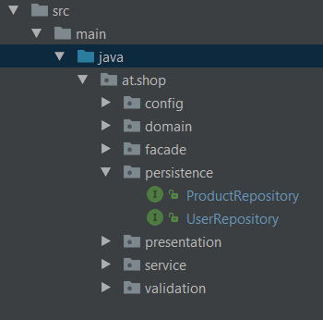 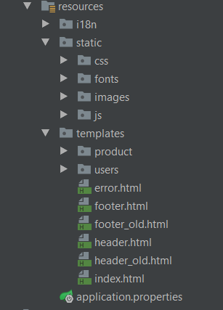

On the left side, the java directories can be seen with the architecture used. On the right side, the resources directories are shown. The façade pattern architecture is used, so any changes on the business logic are done in the façade classes. The domain layer consists of the user and product entities, the repositories use JPA to provide all needed functions between the plain Java objects and the relational database. The services are the interfaces between the façade and the repositories by providing the CRUD operations. In the presentation layer the controllers exist to use the façades to provide the corresponding views by operating in the way needed. The configurations for the web functions and the Thymeleaf engine are made in the config directory. As an additional feature validators were written to provide a wider control on the validation.

The resources are self-explanatory as they provide the resources needed to present the website.

Requirements:

1. Existing user should be able to login with username and password:

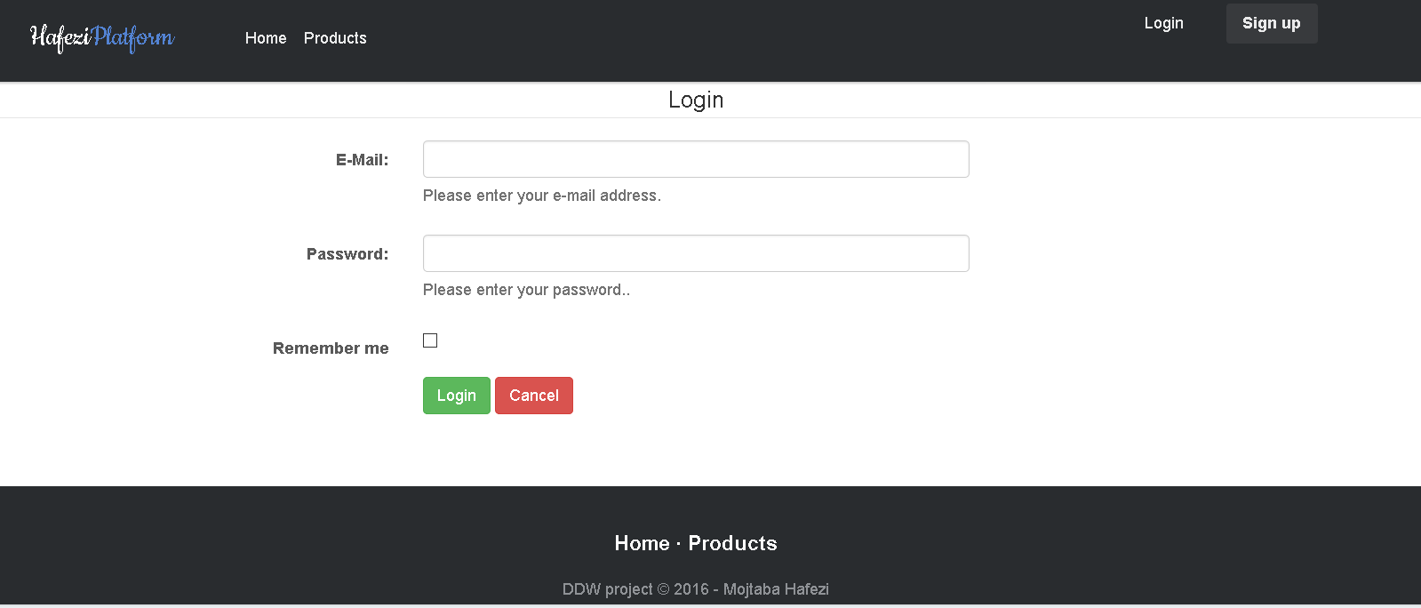

After successful login the user gets redirected to the previous page he came from or the standard page if the corresponding rights are not available. On the right upper corner one can see the email address used to login – this could easily be changed for a username etc.

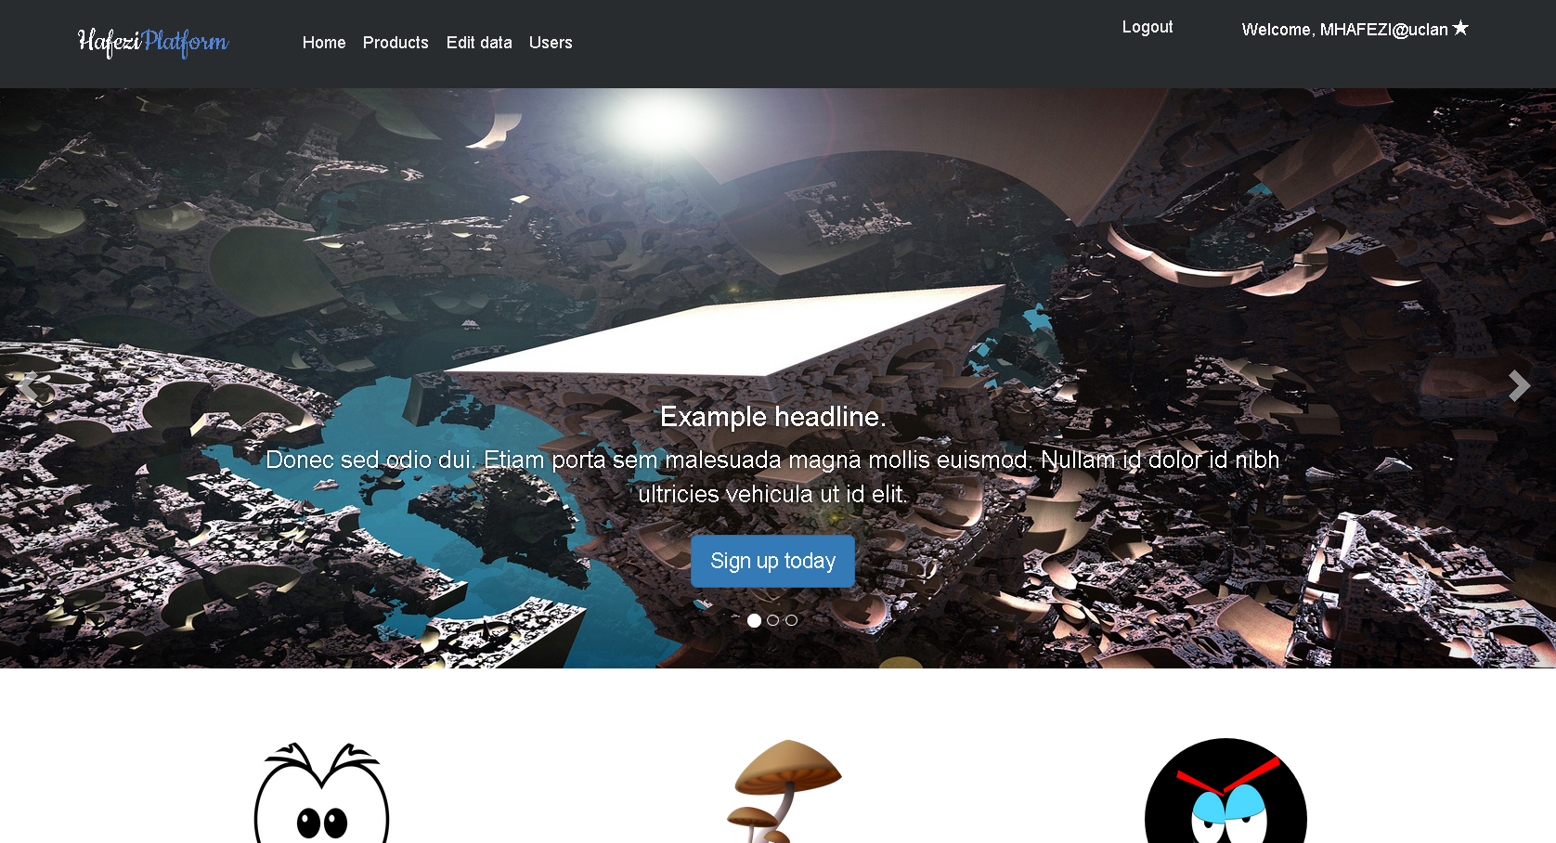

1. Registration of users with username and password:

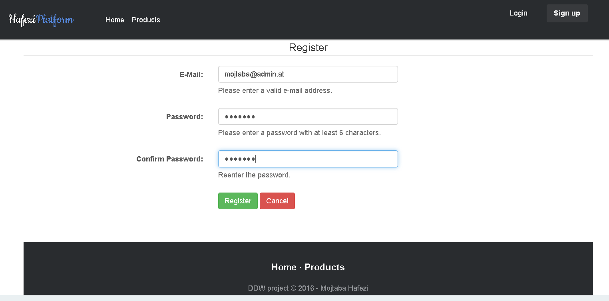

After successful registration the user stays logged in and gets redirected to the homepage.

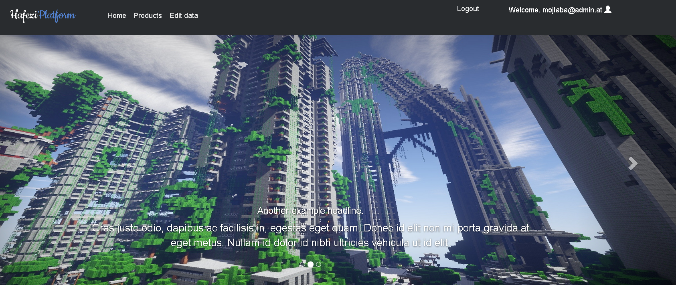

1. Persistent state between pages:

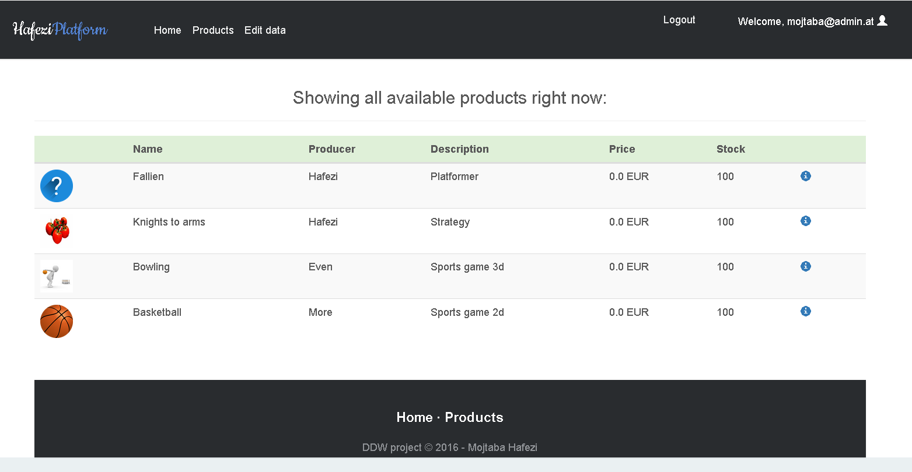

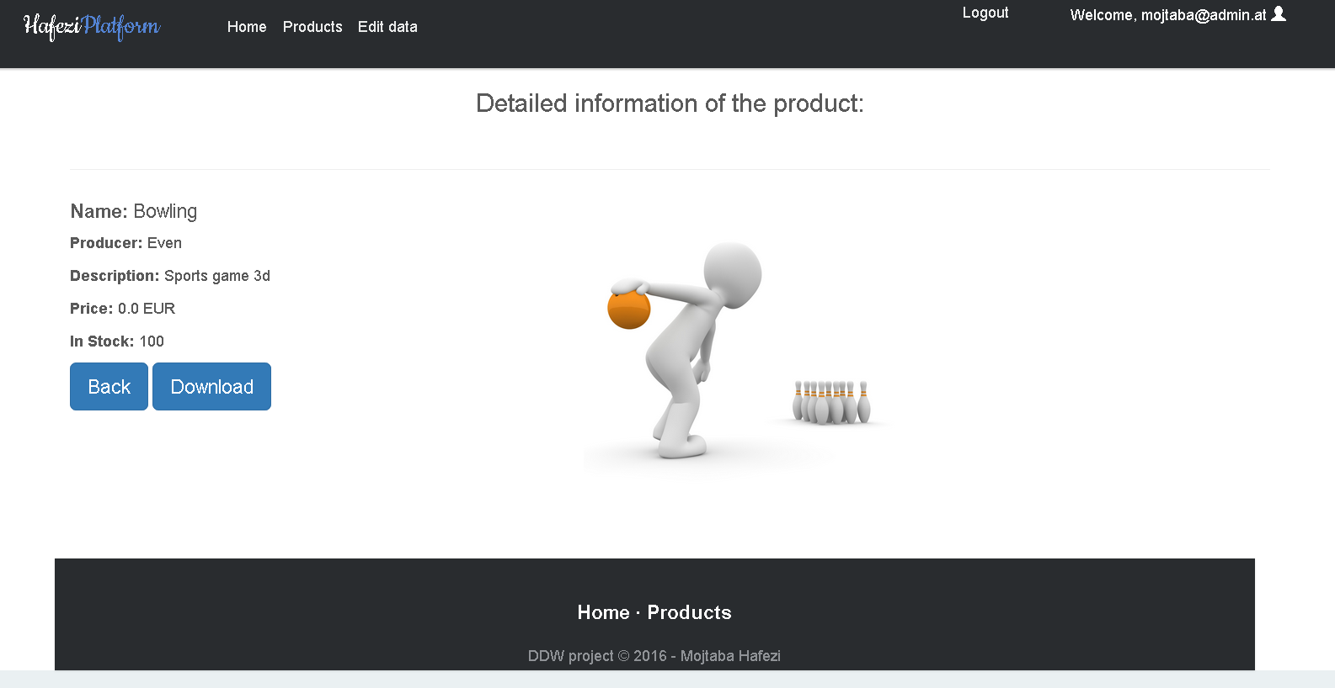

By clicking on the information icon (which only logged in users can see) the user gets forwarded to the detail page where a download function is available to get the showing picture.

1. Minimum of 2 MYSQL tables for data:

The MYSQL database has 2 tables which are user and products. The user contains the email addresses, the hashed password and the role. The products contain more information about the product with the URL to the picture.

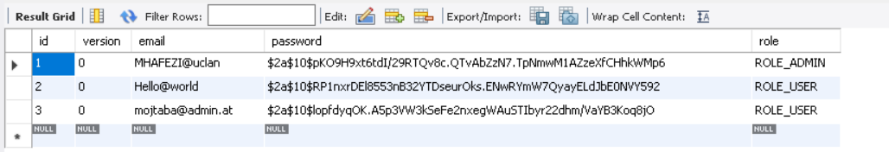

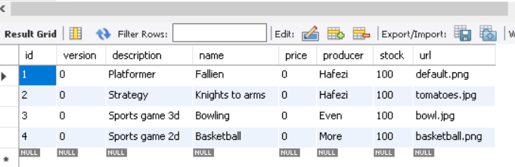

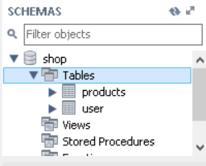

1. No deprecated methods for connections

By using the spring boot application with correct configuration the connection to many databases is possible be it SQL or NOSQL databases.

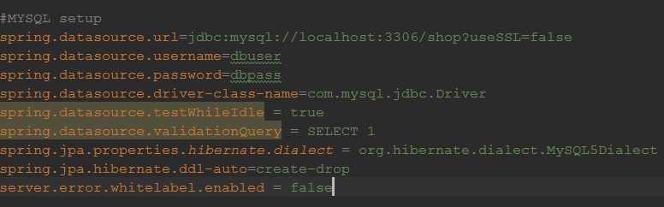

The dependencies must be configured correctly too. As one can see, the SSL is disabled for development process. Furthermore the username and password chosen are not safe.

1. Server and client side validation:

Server validation: By extending the Spring Security validators and adding additional checks the server validation works without problems.

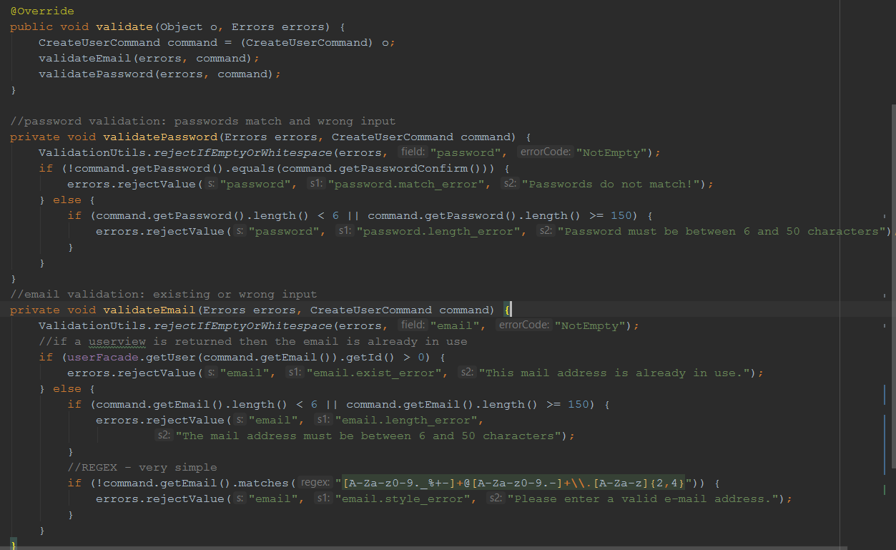

To get the validators working in the controller classes they need to be declared correctly:

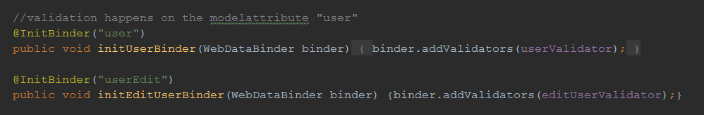

This way the Model attributes “user” or “userEdit” have their corresponding validation. With this approach, custom validation can be added to the already included domain validations:

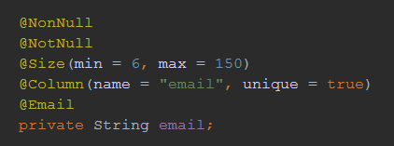

This code catches all problems occurring and forwards it to the BindingResult to provide the information on the views. Different Validators are used for different validation on users and products.

On the client side, I decided to use HTML-validation. Next to auto-populating by giving the “th:placeholer” the current attribute of the field, I also set the min and max values in addition to a simple regular expression for a field of the type DOUBLE.

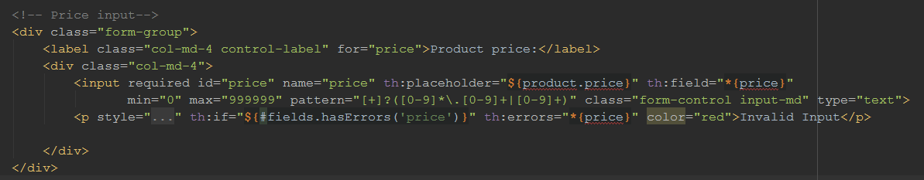

The required statement in the input demands information from the user and thus the form cannot be submitted without all required fields filled out. With the use of corresponding patterns the minimum length of characters for passwords and other product details are secured. The email has its own validation through a regular expression.

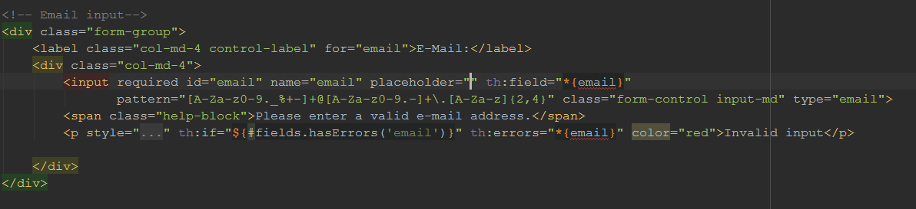

Every form is validated with both approaches for client and server side validation.

Validations can be found in the domain classes, the validators and all views (htmls) with a form.

1. CRUD operations on data:

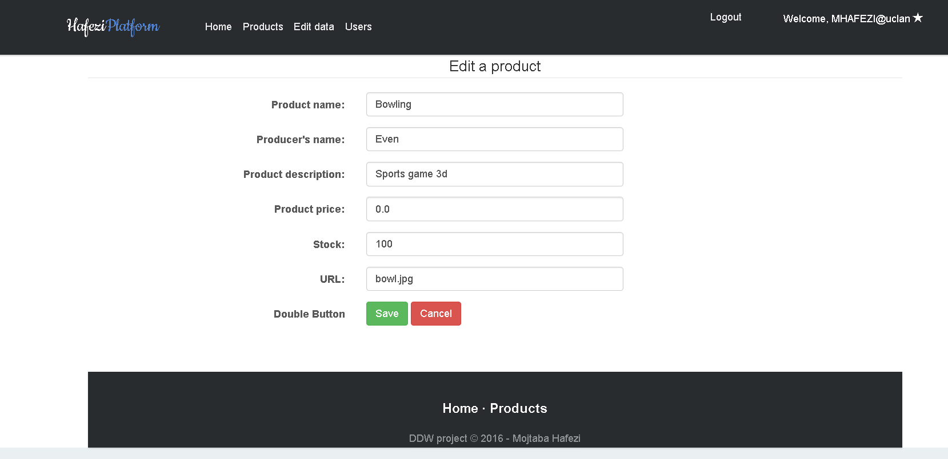

A **broad range** of information can be changed. The employees and administrators can operate all CRUD operations on the products, while the users can only be viewed and changed by the admin.

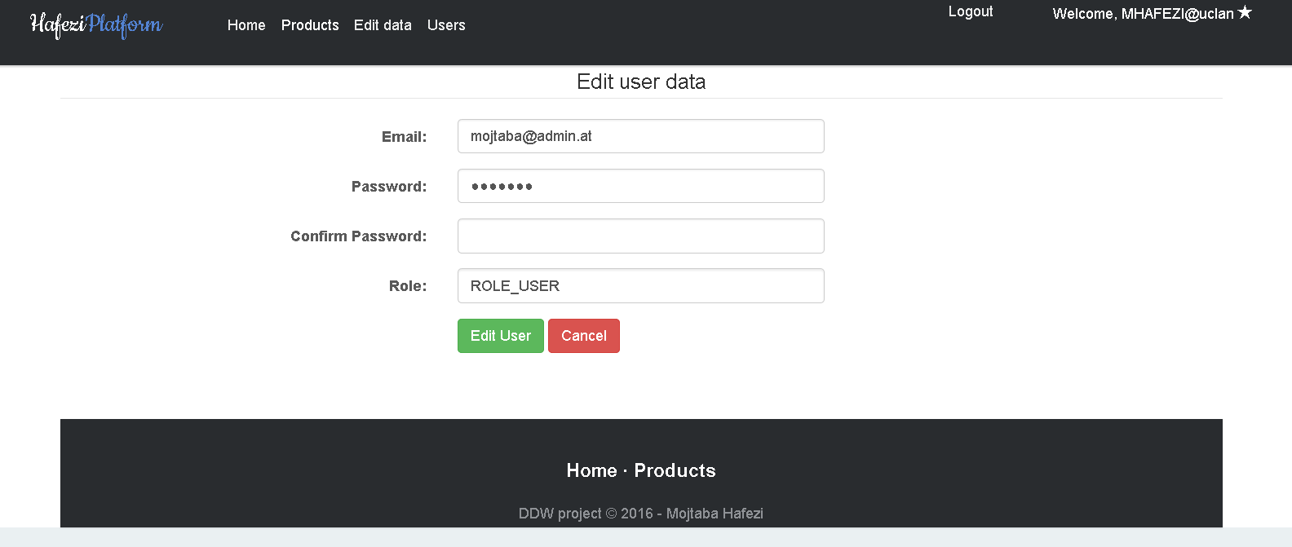

Some of the fields get **auto-populated**. This is provided mostly through the server but also the html placeholder comes in use (for products for example). Especially in the edit forms the fields are auto-populated to reduce the workload on the users (changes on users or products alike).

The source code for the crud operations are all in the façade classes which make use of the services.

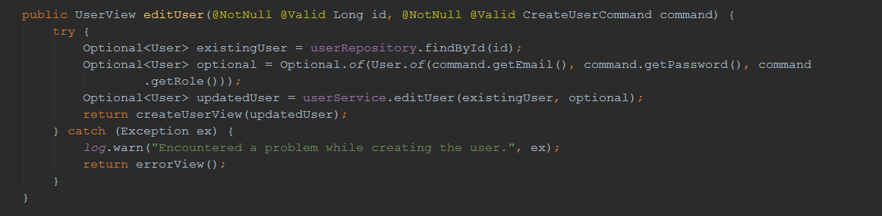

1. Different users with different rights/views:

To begin with I provide three roles: User, Admin and Employee. The employee can change product data and their own user data like password or email. A normal user has no CRUD rights on any data but his own login credentials. The admin has CRUD rights on all tables and can see the list of users etc.

The admin is marked on the upper right corner by a star and the navigation bar shows more options:

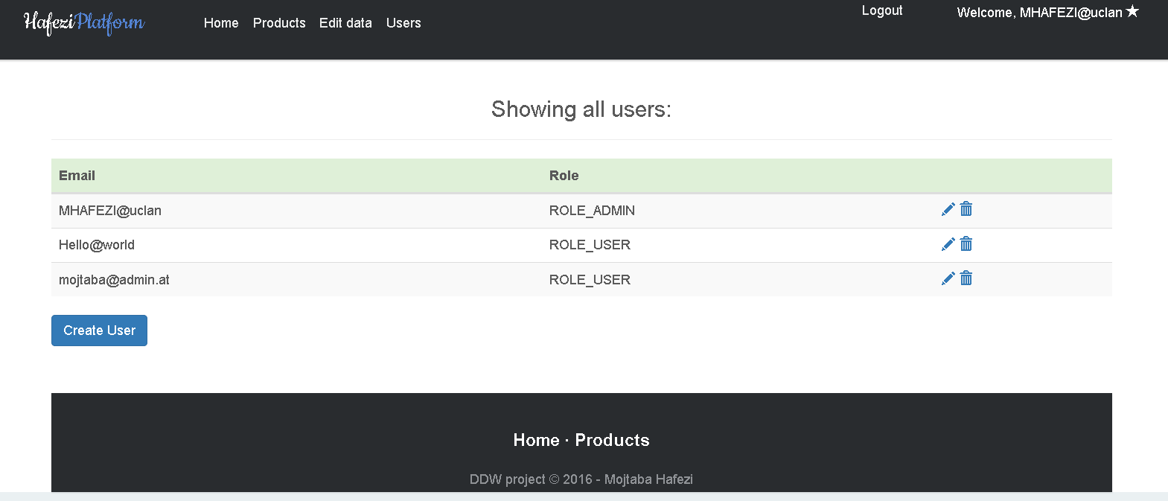

The employee is marked with the sunglasses and has fewer options for changes.

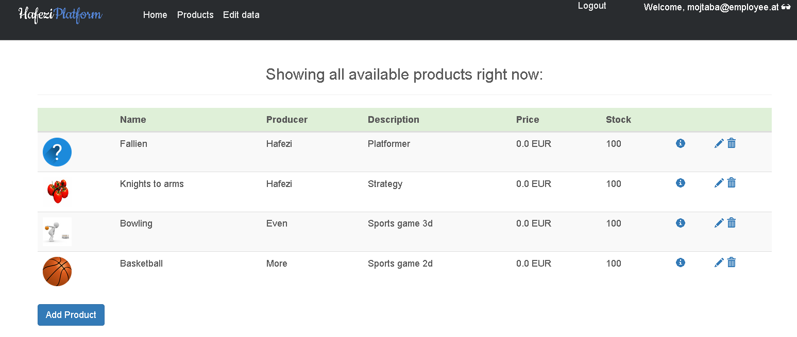

The user marked with a user icon, can only edit his/her own data and view/download the products.

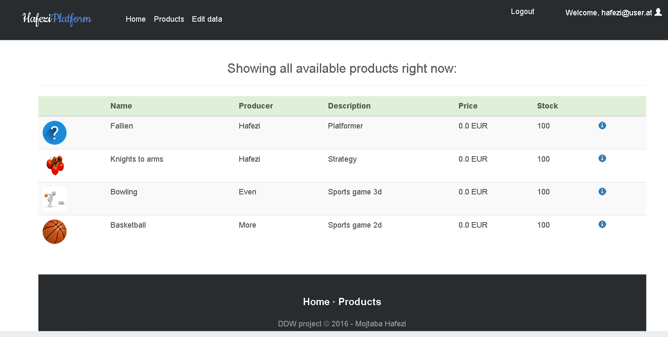

To make this possible different approaches were used. Not only the spring security authorization, which is configurable by telling spring which URLs are restricted for which users, but also Thymeleaf security and the method authorization has been implemented.

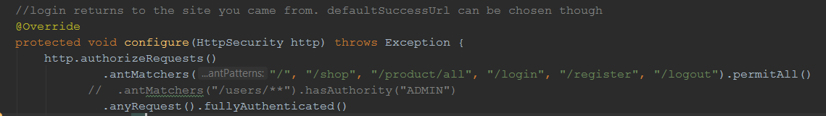

With the commented “.antMatchers()” method one can add as many URLs with the corresponding authority.

In the situation, a user wants to edit his own credentials but is not an admin, the approach shown above wouldn’t make it possible for a simple user to change anything. In this scenario, following approach solves the problem in an elegant way:

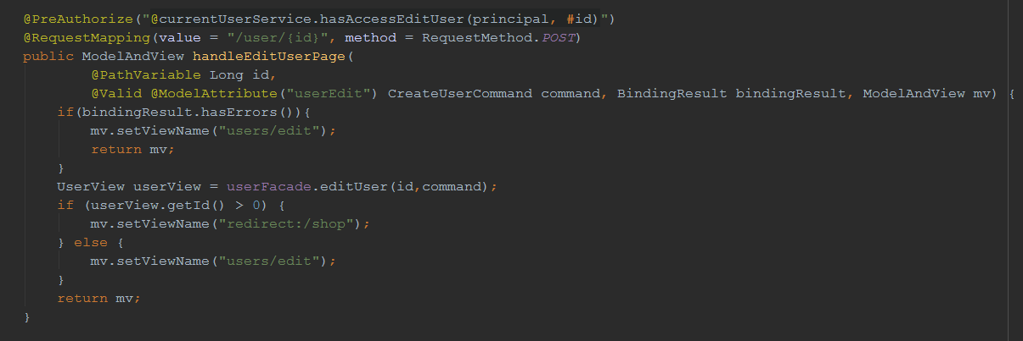

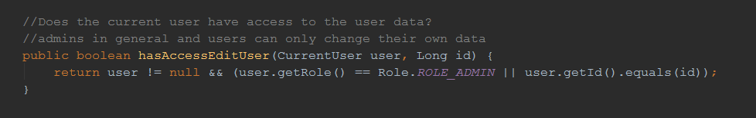

With the “PreAuthorize” I ask the spring security to check if the method “hasAccessEditUser” returns true or false in the CurrentUserService class (which needs to extend the UserDetailsService to get called with the annotation). So when a normal user clicks on “Edit Data” on the website to change his own email address or password, his id is used for the get (afterwards post) request and if either the role fits or the id then the access is granted. The integration of spring security here is of importance as the principal is the currently authenticated user.

1. Secure password hashing with additional salting:

After researching many hashing algorithms and possibilities in java I came to the conclusion to use the BCrypt hashing algorithm. It has a salting function, which makes the passwords very safe. There is no way to decode the hashed algorithm so the match function gets used to check for correctness of the passwords. CSRF_Token was also enabled for better protection.

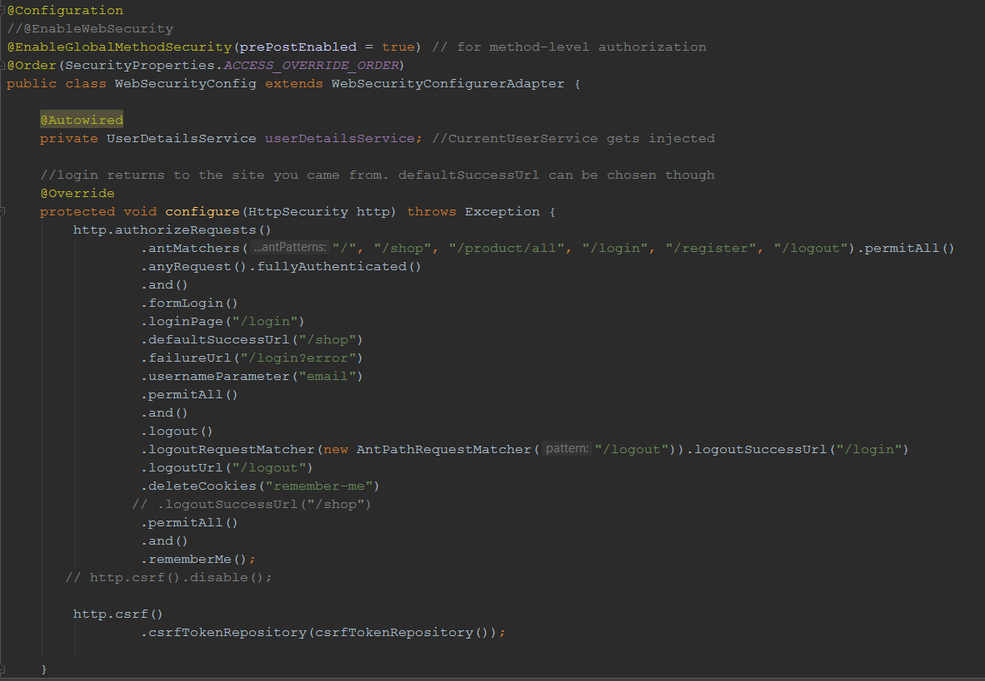

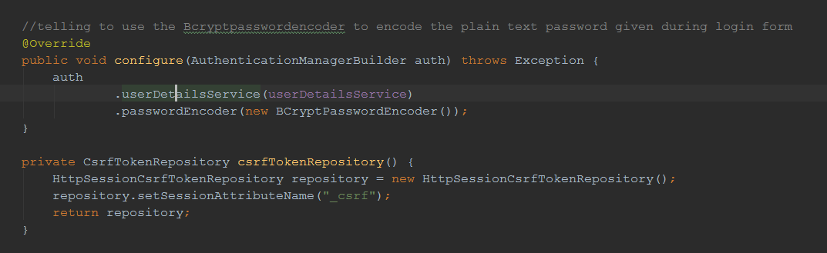

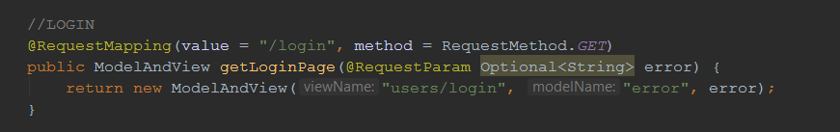

Login Process: The user opens the /login URL and fills up the form to submit it. Meanwhile the LoginController returned a view with the form and after submitting the data the loadUserByUsername() gets called by the UserDetailsService (which I implemented with the CurrentUserService class). The username (as in the configuration shown equals the email) is given to the load method and the CurrentUser is returned from the Service layer. Afterwards the getPassword() method gets called and the comparison with the saved hashed password happens with the matches() method of the BCryptPasswordEncoder class. If any problems occur, the URL is set to login?error where the message “Username or Email is wrong”. The actual problem is not visible to make it more secure against intruders. Further details can be viewed in the code section.

1. Additional security features:

To prevent Cross-site request forgery a CSRF token is created in a cookie, which is deleted after the user logs out again. To make this possible, proper HTTP verbs like GET and POST are used through the complete website. Using the configure method in the WEBSECURITYCONFIG class the application ensures any request to the application requires authentication for specific URLS and allows form based login. Furthermore, the logout is handled by invalidating the session, deleting cookies and redirecting to the login page.

1. Additional performance feature:

Caching enabled for specific methods of the repository (get all users for example etc.). Furthermore, by using sprites the performance can be increased a lot. I provided these for the three background images used in the carousel of the home page. By adding all three backgrounds in one picture and using css to determine where each background starts, not only are all three pictures loaded by one single HTTP call but also reduces the overhead and bandwidth used.

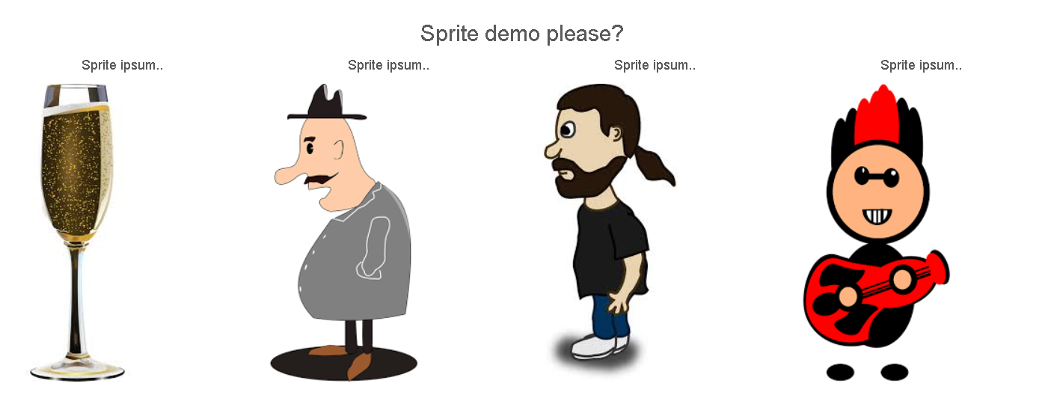

Depending on the images used and the sprite created the performance increase differs. In this example the sprite is about 120KB bigger in size but reduces the calls needed from four to only one.

This can be easily accomplished using css like in the presented demo or special tools.

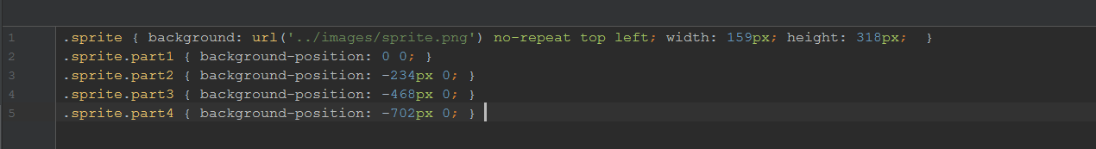

1. Design, usability and layout:

A well designed website is provided with responsiveness and thorough usability. More pictures are added in the appendix.

Appendix A:

Pictures of the website with different logins and views are added for a better overview.

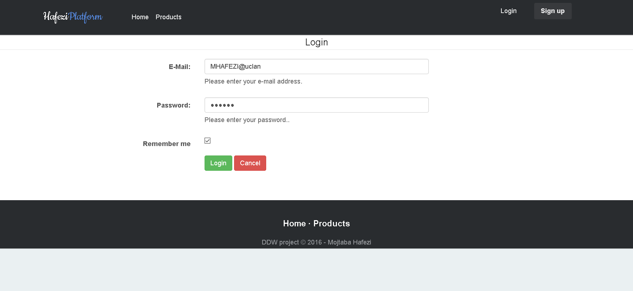

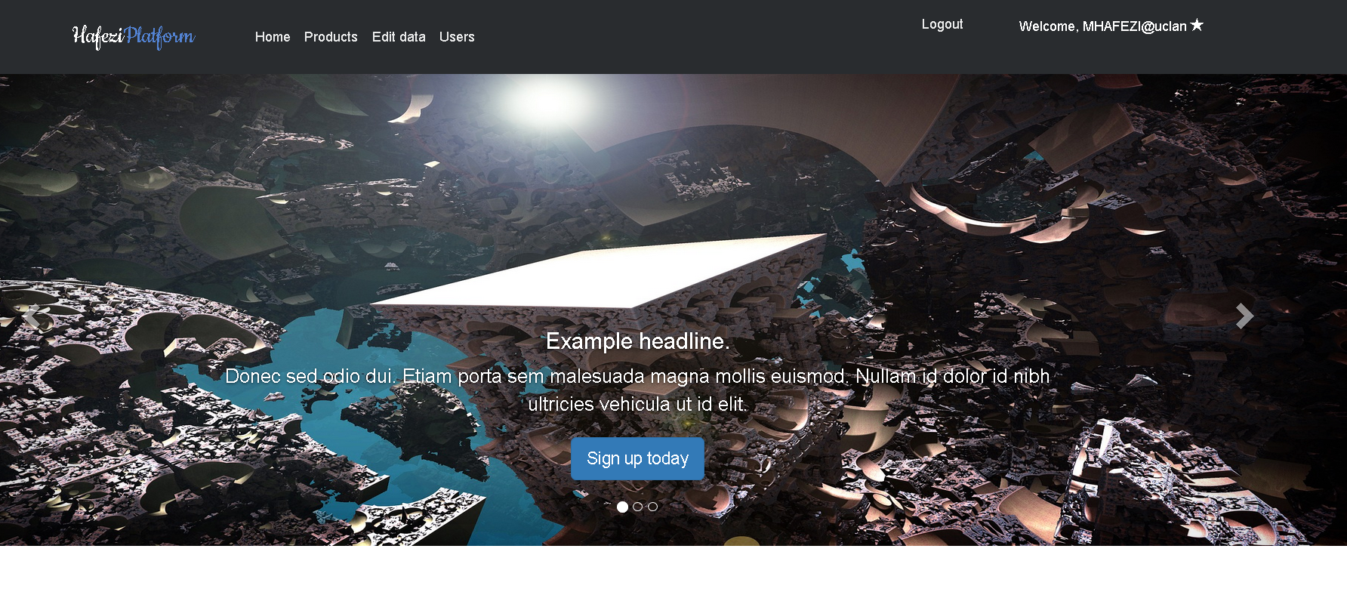

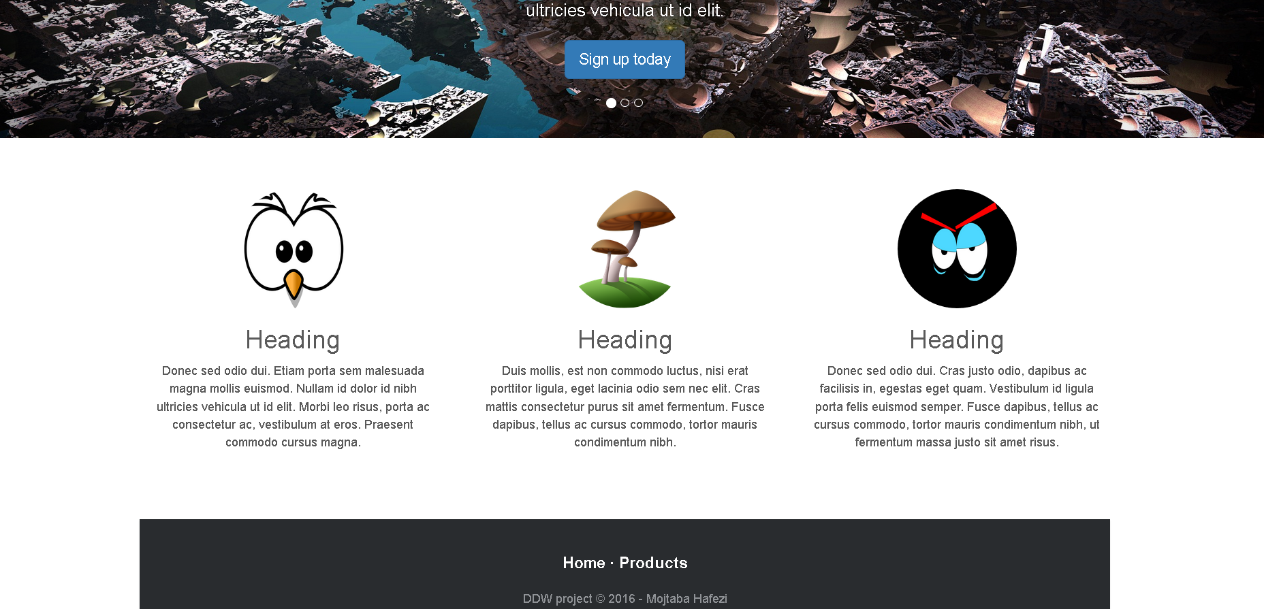

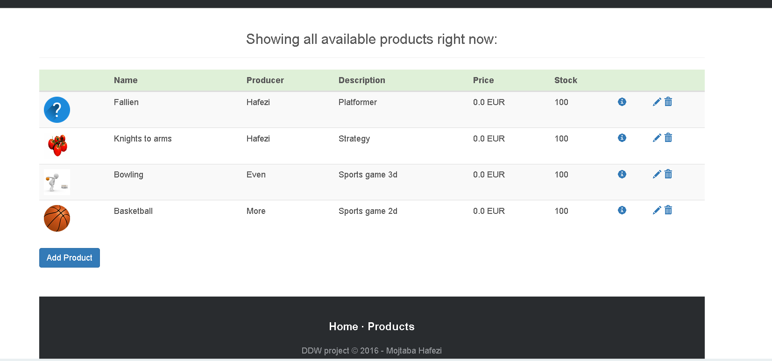

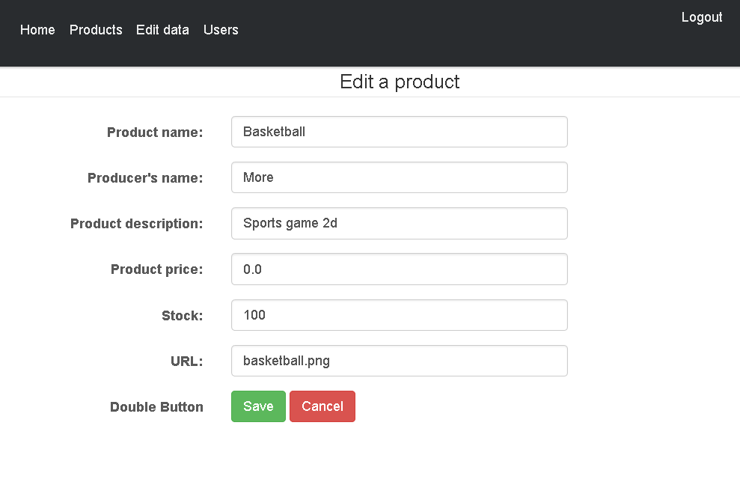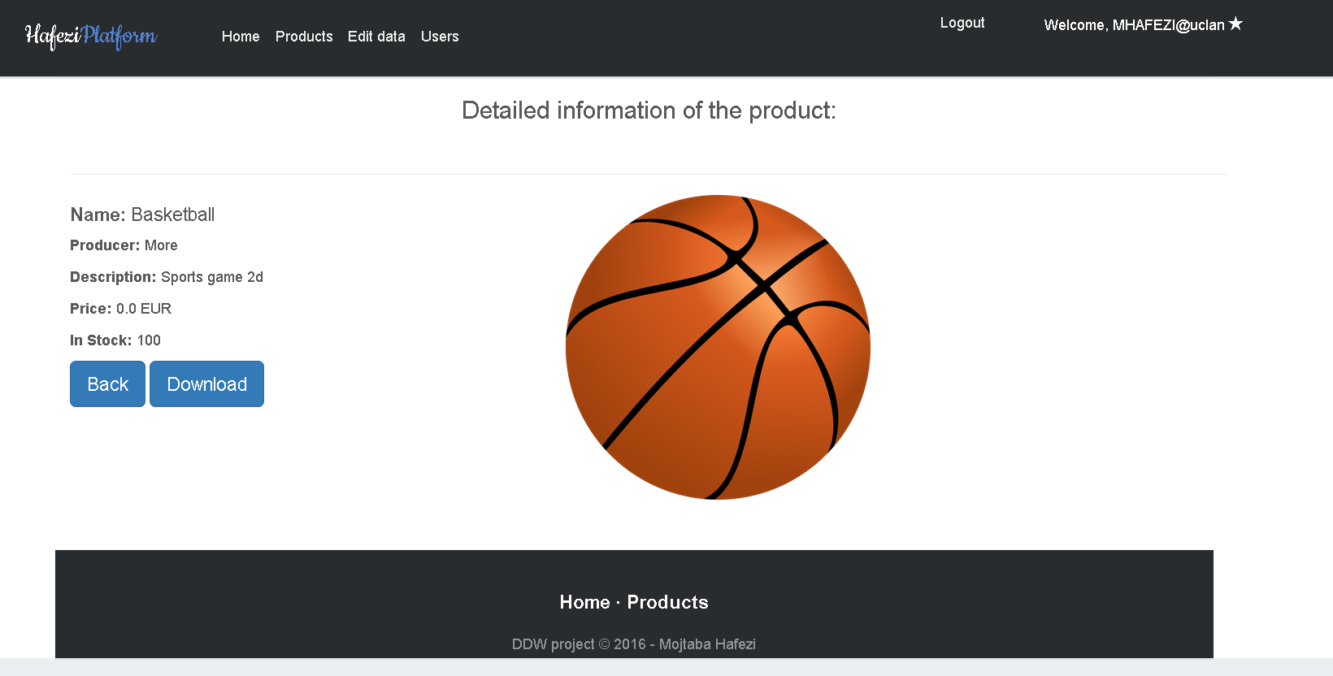

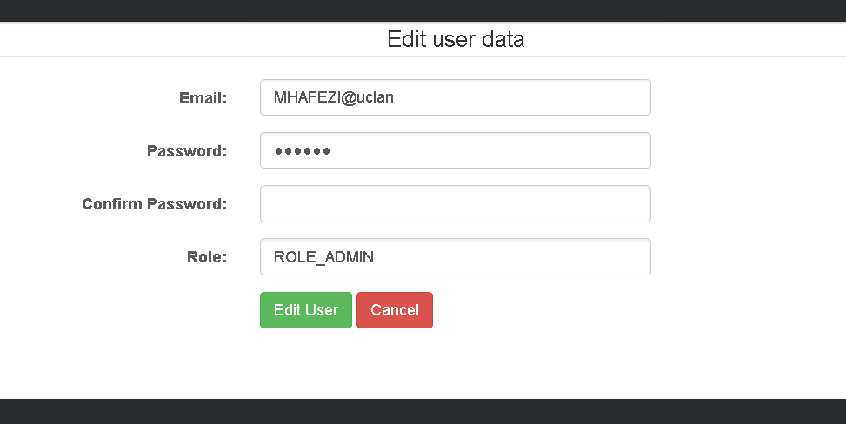

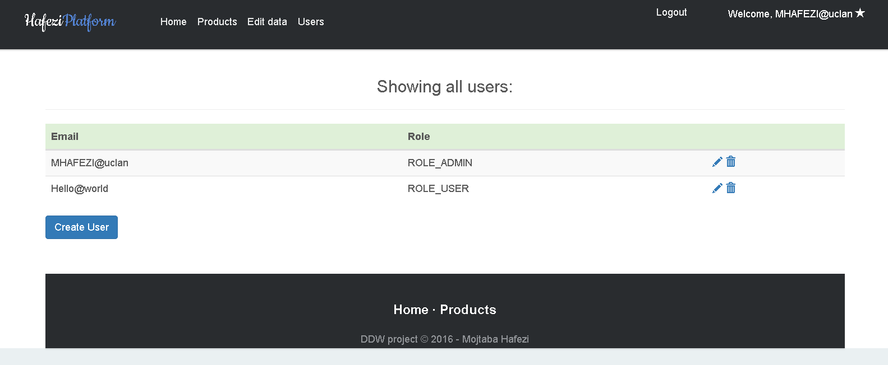

The last picture shows the project structure with the multi layered project structure.

